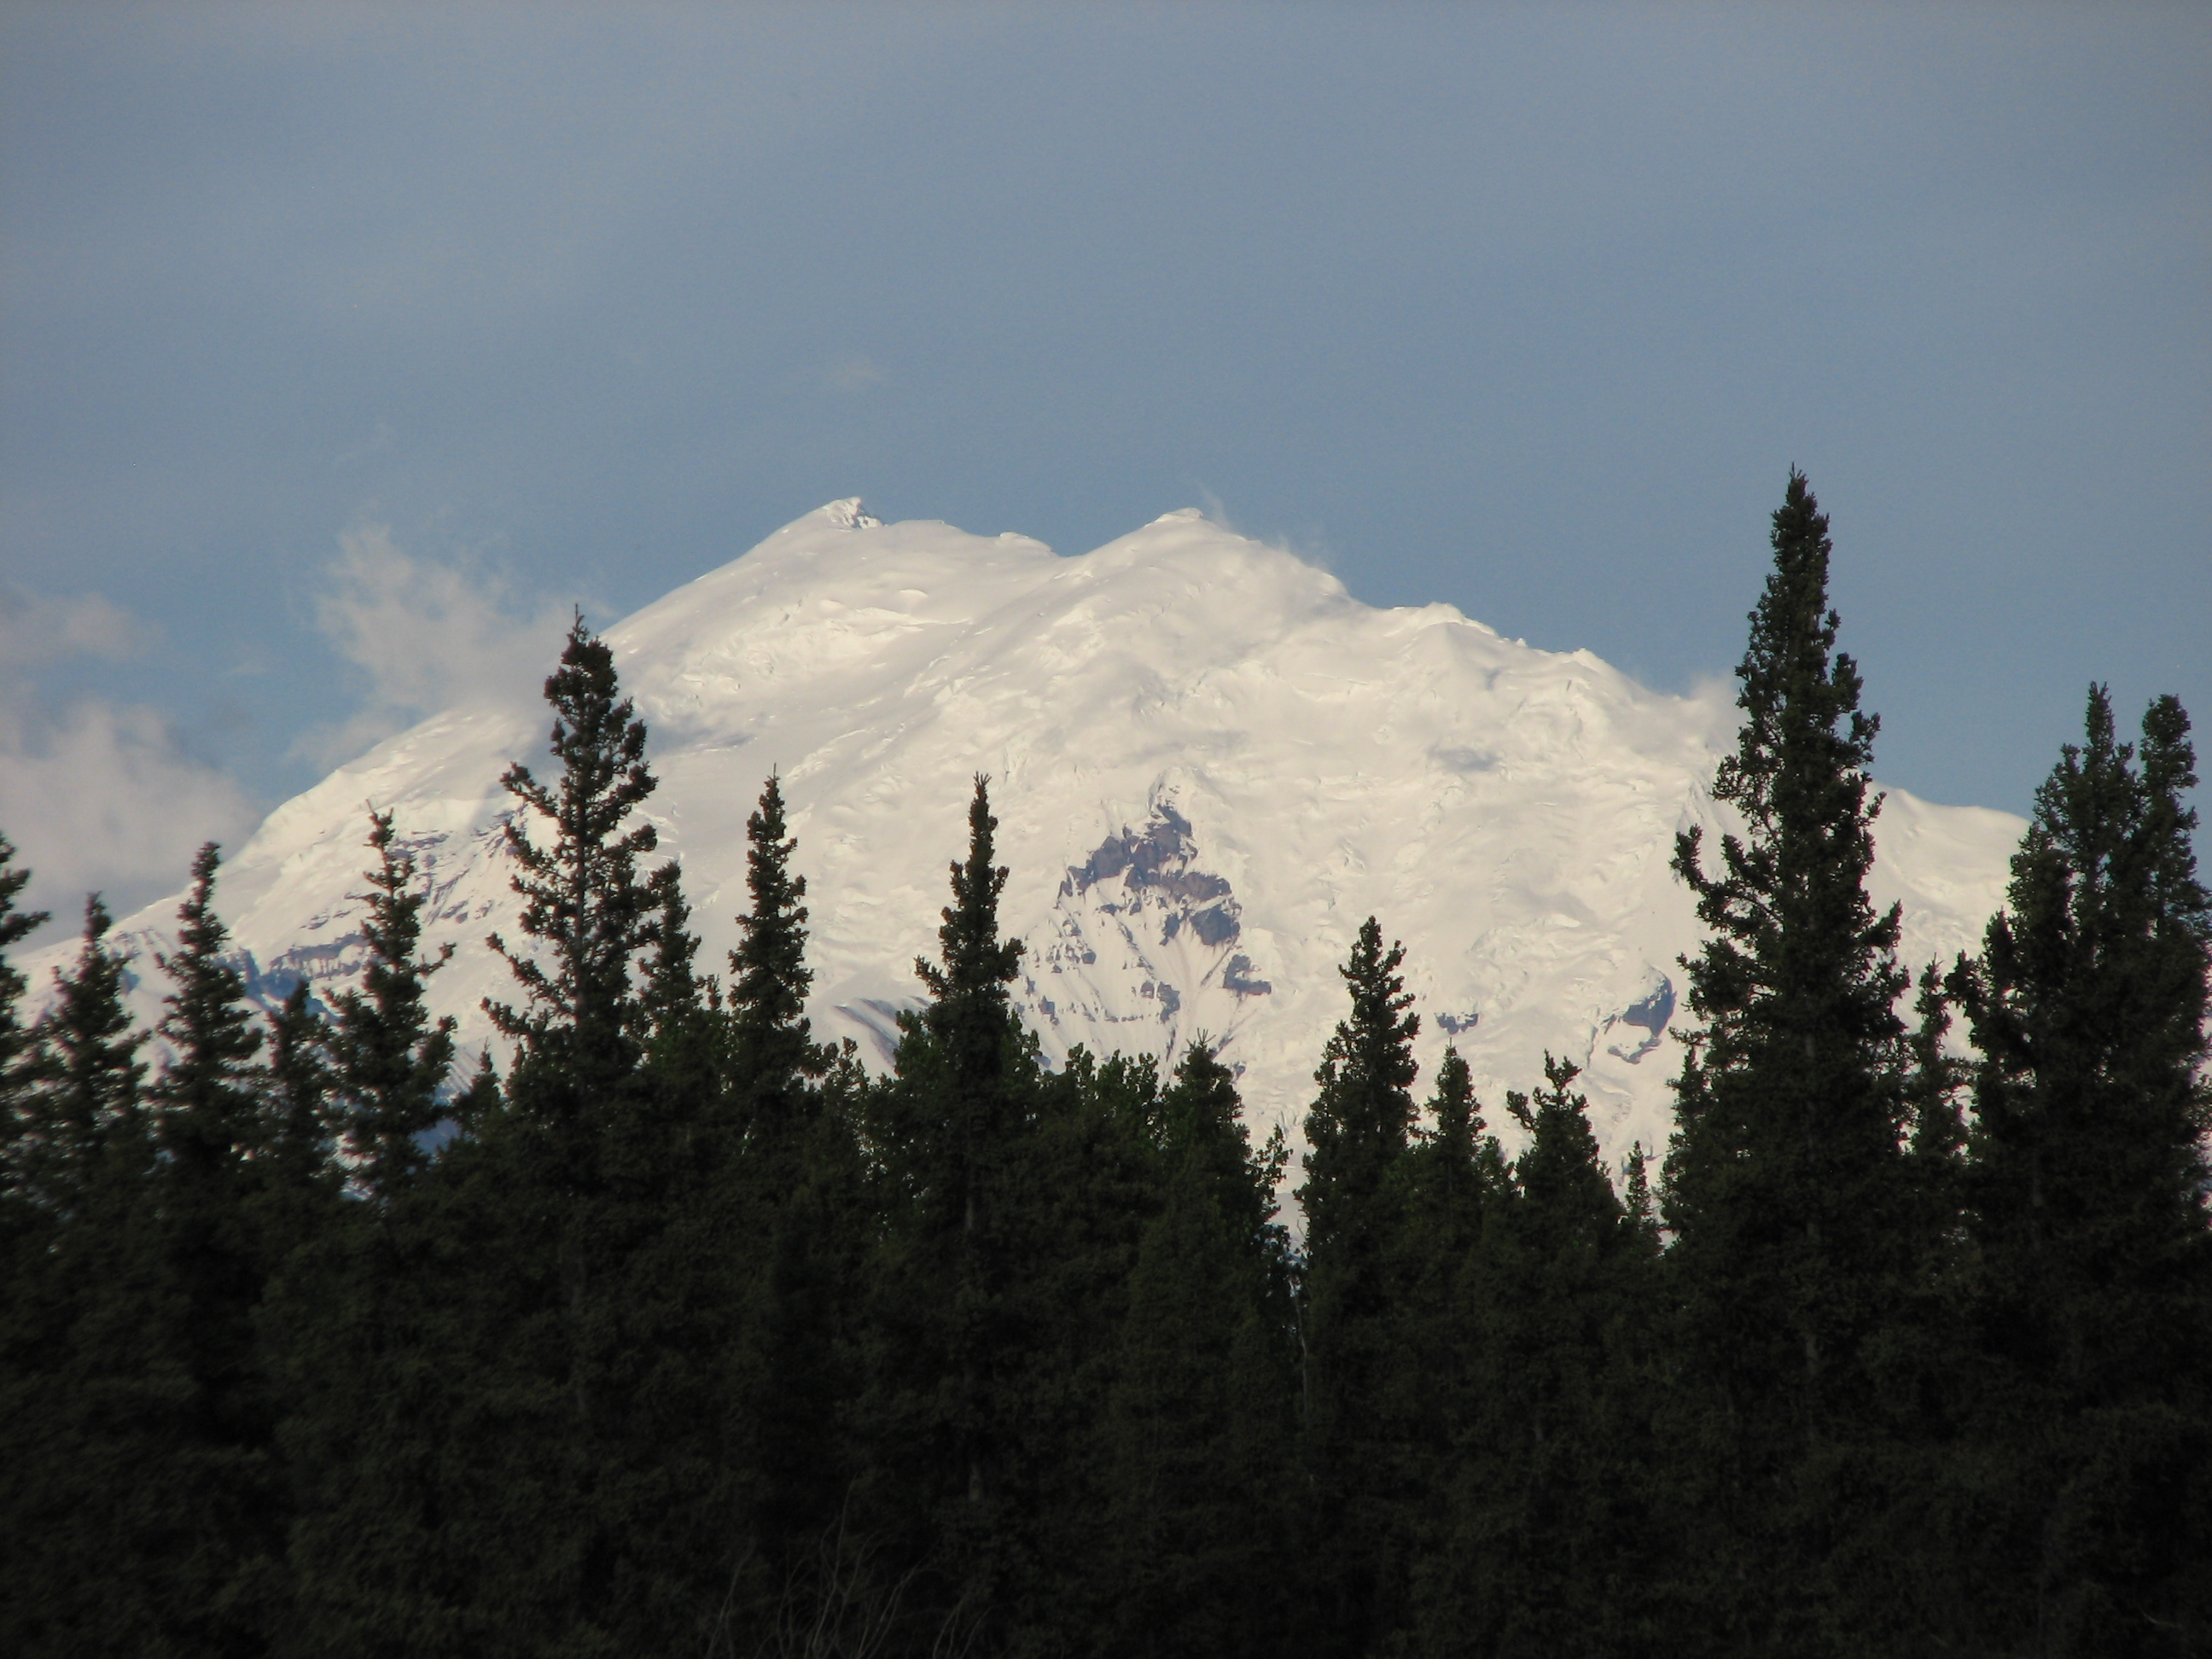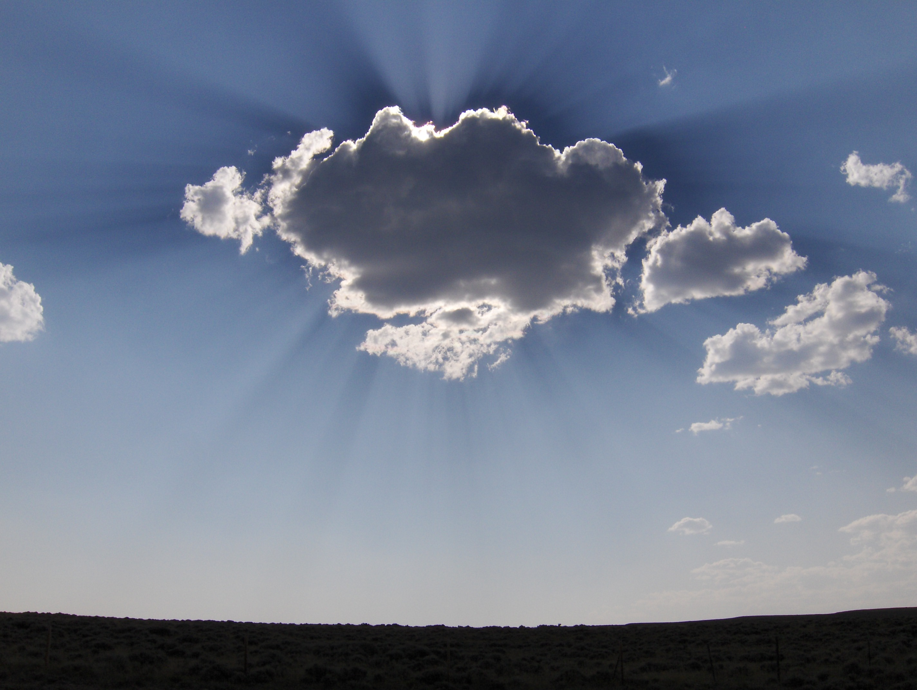

* ~~Grades 10-12~~
* ~~1 Credit~~
* ~~This course will count as a required English credit. However, this course is optional. (Students can take also take English 9-10 or 11-12 to fulfill this requirement.)~~
* ~~The course website will include descriptions of assignments and online discussion boards. Students will be required to use it, and parents are welcome to follow along as well.~~

**~~www.GlennallenAP.weebly.com~~**

* ~~Apex Learning – www.apexvs.com~~

Details

AP English Literature and Composition is a year-long course in which students’ reading, writing, and oral skills are strengthened through the study of novels, plays, poems, and short stories from the sixteenth century to the present. This course will be demanding, and will require a great deal of reading, writing, and participation in multiple forms of collaborative learning. Students can expect to spend *at least* an hour every night working on course material, doing assigned reading, preparing for class discussions, and developing critical written responses to literature.

Content for this course comes from the APEX Learning AP English Literature and Composition course. Some students may be familiar with this online program from the AP English Language and Composition course used last year. However, though the content will come from this online source, this course will not be an independent study. We will use a blended approach – material will be discussed and evaluated in class, and online components will be utilized as well.

## Exploring Literature

Mr. Tim Shumway Rm. 207 tshumway@crsd.us 822-5286

AP English Literature & Composition

“A child said *What is the grass?* fetching it to me with full hands;  
 How could I answer the child? I do not know what it is any more than he.”  
 - Walt Whitman, *Song of Myself*

**Important Note About Materials:** This is an advanced level course, and as such students will be responsible for purchasing their own texts for the class so that they may annotate and mark pages as needed. A limited number of copies of texts may be available for loan to students who are unable to purchase their own texts due to financial hardship. This includes anthologies, collections, and novels. **A list of required texts and purchase information is attached.**

**Quarter One:**

[**1. Getting Started**](javascript:loadOutline(311660519);)  
 Introduction to the course and to the AP Test format.

[**2. Fiction and Poetry: Literature of Examination**](javascript:loadOutline(311660542);)  
 “Araby” by James Joyce  
 “The Story of an Hour” by Kate Chopin   
 “Sweat” by Zora Neale Hurston  
 “High Holy Days” by Jane Shore  
 “The Collar” by George Herbert   
 “Design” and “The Most of It” by Robert Frost

[**3. Drama: Lives in Crisis**](javascript:loadOutline(311660572);)  
 *Hedda Gabler* by Henrik Ibsen  
 *A Streetcar Named Desire* by Tennessee Williams

[**4. Poetry: Love and Separation**](javascript:loadOutline(311660601);)  
 “Corinna’s Going A-Maying” by Robert Herrick  
 “The Sun Rising” by John Donne  
 “To His Coy Mistress” by Andrew Marvell  
 “My Last Duchess” by Robert Browning  
 “since feeling is first” and “in Just-“ by e.e. Cummings  
 “I, Being Born a Woman, and Distressed” by Millay  
 “Girl Powdering Her Neck” by Kathy Song

**Quarter Two:**

[**5. Long Fiction: Their Eyes Were Watching God**](javascript:loadOutline(311660638);)  
 There Eyes Were Watching God by Zora Neale Hurston

[**6. Drama: Shakespearean Comedy**](javascript:loadOutline(311660664);)  
 *Twelfth Knight* by William Shakespeare

*Review & Mid-Term Exam*

**Quarter Three:**

[**7. Victorian Era Literature**](javascript:loadOutline(311660709);)  
 Jane Eyre by Charlotte Bronte

[**8. 19th-Century Literature: British & American Authors**](javascript:loadOutline(311660737);)  
“The Tyger” and “London” by William Blake  
“My Heart Leaps Up” and “The World is Too Much With Us” by   
 William Wordsworth  
“Ozymandias” by Percy Shelly  
“Kubla Khan” by Samuel Colleridge  
“Ode to a Nightingale” by John Keats  
“258,” “280,” and “986” by Emily Dickinson  
“Song of Myself (1, 6, & 52)” by Walt Whitman  
“Bartleby, the Scrivener” by Herman Melville

[**9. Turn-of-the-Century Literature**](javascript:loadOutline(311660766);)  
 “Heart of Darkness” by Joseph Conrad  
 “An Image of Africa: Conrad’s ‘Heart of Darkness’” by Chinua Achebe  
 “The Yellow Wallpaper” by Charlotte Gilman  
 “A Feminist Reading of Gilman’s ‘The Yellow Wallpaper’” by Gilbert   
 & Gubar  
**Quarter Four:**

[**10. Modern Literature**](javascript:loadOutline(311660793);)  
 “The Darkling Thrush” by Thomas Hardy  
 “God’s Grandeur” by Gerard Hopkins  
 “The Second Coming” by William Butler Yeats  
 “The Love Song of J. Alfred Prufrock” by T.S. Eliot  
 “When You Are Old” by William Butler Yeats  
 “Thirteen Ways of Looking at a Blackbird” by Wallace Stevens  
 “Sea Violet” by H.D.  
 “The Red Wheelbarrow,” “The Dance,” and “This is Just to Say”   
 by William Carlos Williams  
 “Variations on a Theme by William Carlos Williams” by Kenneth Koch  
 “Incident” by Countee Cullen  
 “Dream Variations” by Langston Hughes  
 “Reapers” by Jean Toomer

[**11. The American Dream**](javascript:loadOutline(311660821);)  
 The Great Gatsby by F. Scott Fitzgerald  
 “Harlem” and “Theme for English B” by Langston Hughes

[**12. Contemporary Literature**](javascript:loadOutline(311660845);)  
 “Sonny’s Blues” by James Baldwin  
 “I Stand Here Ironing” by Tillie Olsen  
 “The Fish” and “In the Waiting Room” by Elizabeth Bishop  
 Excerpts from The House on Mango Street by Sandra Cisneros  
 “Two Kinds” by Amy Tan  
 “A Very Old Man With Enormous Wings” by Gabriel Garcia Marquez  
 Annie John by Jamaica Kincaid

**Review & AP Exam**

What happens to a dream deferred?

Does it dry up

like a raisin in the sun?

Or fester like a sore –   
 And then run?

Does it stink like rotten meat?

Or crust and sugar over –

like a syrupy sweet?

Maybe is just sags

like a heavy load.

*Or does it explode?*

### Units of Study

“Harlem” by Langston Hughes

Grades will be based on a total points system. Each assignment will be given a point value depending on its importance and length. Items will include, but will not be limited to the following:

* Reading Responses
* Class Discussion
* Informal Essays /   
  In-Class Writing
* Formal Essays
* Extended Projects
* Exams

At the end of each marking period, the percentage of points earned will determine the grade in the class.

According to district policy:

90-100 = A – Outstanding   
80-90 = B – Above Average  
70-80 = C – Average   
60-70 = D – Below Average  
0-59 = F – Little Achievement

Extra credit will not be available. However, students will be allowed (and encouraged) to revise most written work to improve scores on individual assignments.

*Late work will be accepted, but will be reduced one full letter grade.

Grading Policy:

A Note on Standards:

This course will address Common Core Standards for English Language Arts in the 11-12 grade band, with special emphasis on Reading Literature, Writing, and Listening and Speaking standards.

***Class Routine:***

*Before the bell –*

*Come to class on time and be*

*prepared with everything you need.*

*When the bell rings –*

*In your notebook, write down the daily objective and then begin on the responsive prompt on the board.*

*Throughout class –*

*Participate! Be an active note-taker, and engage in our activities and discussions.*

*End of class –*

*In your notebook, write a short summary of the class, and in your agenda book, record your homework.*

Discussions, both in-class and online, are an important component of this course. Literature lends itself to multiple interpretations, and each individual brings a unique perspective, thereby enriching the entire class’s experience with the text. Students will be encouraged to offer opinions by offering textual support. Participation in discussions is required, and will be scored using a simple rubric.

Participation Expectation:

Absent?

If you are absent, it is *your* responsibility to get the work you missed. Often, this can be found on the class website. You can also seek out classmates or the teacher to help you get caught up.

*Please fill out, detach, and return this page, indicating that you have read and understand the guidelines for this course.*

Student Name: ___________________________________________________________

Student Email Address: _____________________________________________________

*_______________________________________________________ __________________   
Student Signature Date*

Parent/Guardian Name(s): ___________________________________________________

Parent/Guardian email address: _______________________________________________

*_______________________________________________________ __________________  
Parent/Guardian Signature Date*